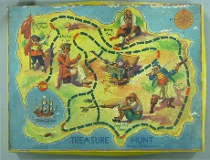 -1-
Find the location encrypted in the clue below and go to there for the next clue
19-3-8-15-15-12 7-1-20-5
COME BACK HERE AND PERFORM FOR THE NEXT CLUE

-2-
The location of the next clue is hidden inside the text below. Look for and correct errors in the sentences. The corrections you make will lead you to the location of the next clue.
Last fhursday evining, I come baqk from sctool and when I opaned the doom to my moom, I faund a mobile phane on ny bed. It was white and ret. It didn’t belung ta me. On the screen was a stlange message …

COME BACK HERE WITH THE RIGHT ANSWER FOR THE NEXT CLUE

-3-
In order to move on to the next clue, answer the following riddle
You can find me in seconds, minutes and centuries, but not in days, years or decades. What am I?

-4-
Find the anagrams to answer the question below
Who Myna slipup is shit cholos?
GO AND FIND THE ANSWER - ONCE YOU FIND THE ANSWER GO AND GET THE FINAL CLUE

-5-
10 + 9 x 5 – 14 : 9 - 3
Do the following operations in the right order (one after the other)
Complete the following phone number with the answer : 06 92 …1 76 80
CALL THE NUMBER AND YOU WILL ASK (IN ENGLISH) FOR THE PASSWORD TO WIN THE HUNT

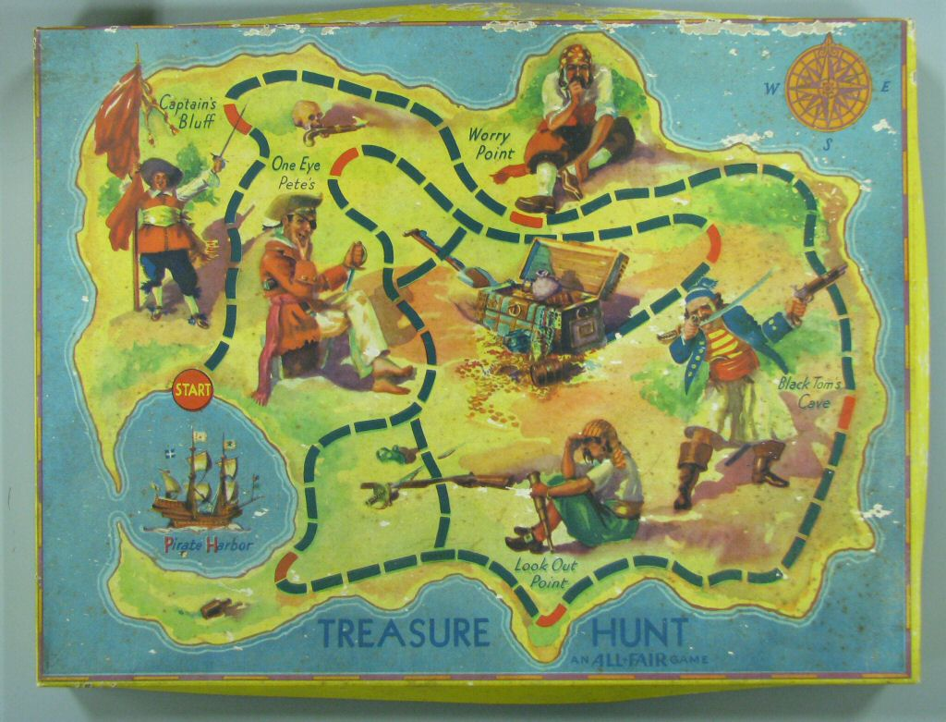

Each team member has to memorize at least one line of the following poem

Until we find the real reason.
The truth will have to do.
We can only know so much.
So there's always something new.

Go to the school library and find the English equivalent to the French proverb

« L’habit ne fait pas le moine »

